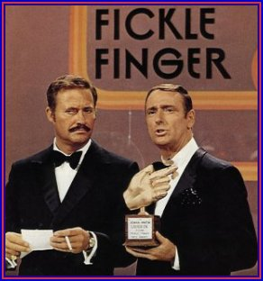

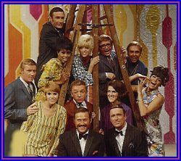
Rowan and Martin’s Laugh In

January 22, 1968 - May 14, 1973
NBC Comedy-Variety Series - 124 Episodes

While reading the play, Director Geoff Nelson thought of “Rowan and Martin’s Laugh In” television show and asked Scenic Designer Stephanie Gerckens to include some elements of that show’s set in CATCO’s stage design.

